Name : Muhammad Taha | CMS ID : 518133

Lesson Set 10 | Introduction to Arrays
Purpose | - Understand the purpose and usage of Arrays.  - Awareness of arrays with syntax and rules.  - Declaration and accessing elements of an array.
Procedure | - Students should read the Pre-lab Reading Assignment before coming to the lab.  - Students should complete the Pre-lab Writing Assignment before coming to the lab.  - In the lab, students should complete Labs 9.1 through 9.2 in sequence.  - Your instructor will give further instructions on grading and completing the lab.  - Students should complete the set of lab tasks before the next lab and get them checked by their lab instructor.
 | Contents | Pre-requisites | Completion Time | Page Number
 | Pre-lab Reading Assignment | - | 20 min
 | Pre-lab Writing Assignment | Pre-lab Reading | 9 min
 | Lab 9
 | Lab 9.1  Working with Arrays | Understanding the Arrays | 30 min
 | Lab 9.2  Working with declaring and accessing the elements | Implementing the arrays | 30 min

Pre-lab Reading Assignment

What is Array | C++ provides a data structure, the array, which stores a fixed-size sequential collection of elements of the same type. An array is used to store a collection of data, but it is often more useful to think of an array as a collection of variables of the same type.  Instead of declaring individual variables, such as number0, number1, ..., and number99, you declare one array variable such as numbers and use numbers [0], numbers [1], and ..., numbers [99] to represent individual variables. An index accesses a specific element in an array.  All arrays consist of contiguous memory locations. The lowest address corresponds to the first element and the highest to the last element.  C++ Arrays Declaration  To declare an array in C++, the programmer specifies the type of the elements and the number of elements required by an array as follows −  type arrayName [ arraySize ];  This is called a single-dimension array. The arraySize must be an integer constant greater than zero and type can be any valid C++ data type. For example, to declare a 9-element array called balance of type double, use this statement −  double balance[9];  Initializing Arrays  You can initialize C++ array elements either one by one or using a single statement as follows –  double balance[5] = {900.0, 2.0, 3.4, 17.0, 50.0};  The number of values between braces { } can not be larger than the number of elements that we declare for the array between square brackets [ ]. Following is an example of assigning a single element of the array −  If you omit the size of the array, an array just big enough to hold the initialization is created. Therefore, if you write –  double balance[] = {900.0, 2.0, 3.4, 17.0, 50.0};  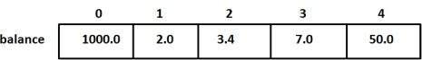  Accessing Array Elements  An element is accessed by indexing the array name. This is done by placing the index of the element within square brackets after the name of the array. For example −  double salary = balance[9];

Pre lab writing assignment
Fill in the blanks | - To store a collection of data of the same type called arrays  - A specific element in an array is accessed by an index.  - The arraySize must be an integer constant greater than zero.  - An element is accessed by indexing the array name

Lab 9
Lab 9.1 | Once you have opened the visual studio copy the following code in the code editor, try to run the code and observe the output. Write down the output that appears on the screen in the space given below  #include <iostream>  using namespace std;  int main() {  int numbers[5] = {7, 5, 6, 12, 35};  cout << "The numbers are: ";  // Printing array elements  // using range based for loop  for (const int &n : numbers) {  cout << n << " ";  }  cout << "\nThe numbers are: ";  // Printing array elements  // using traditional for loop  for (int i = 0; i < 5; ++i) {  cout << numbers[i] << " ";  }  return 0;  }  The numbers are: 7 5 6 12 35  The numbers are: 7 5 6 12 35
Lab 9.2 | Create a new project with new file with name lab9_2.cpp extension, copy the following code it and try to fill the missing code of the program. Observe the output that appears and write it in the box given below  #include <iostream>  using namespace std;  int main() {  int numbers[5];  cout << "Enter 5 numbers: " << endl;  // store input from user to array  for (int i = 0; i < 5; ++i) {  cin >> numbers[i];  }  cout << "The numbers are: ";  // print array elements  for (int n = 0; n < 5; ++n) {  cout << numbers[n] << " ";  }  return 0;  }  Enter 5 numbers:  44  23  65  77  33  The numbers are: 44 23 65 77 33
Lab 9.3 | Create a new project with name lab9_3.cpp extension, copy the following code it and try to run the program. Observe the output that appears and write it in the box given below  #include <iostream>  using namespace std;  int main() {  // initialize an array without specifying size  double numbers[] = {7, 5, 6, 12, 35, 27};  double sum = 0;  double count = 0;  double average;  cout << "The numbers are: ";  // print array elements  // use of range-based for loop  for (const double &n : numbers) {  cout << n << " ";  // calculate the sum  sum += n;  // count the no. of array elements  ++count;  }  // print the sum  cout << "\nTheir Sum = " << sum << endl;  // find the average  average = sum / count;  cout << "Their Average = " << average << endl;  return 0;  }  The numbers are: 7 5 6 12 35 27  Their Sum = 92  Their Average = 15.3333

Lab 9 | Lab Tasks

- Write a C++ program to find the largest three elements in an array.

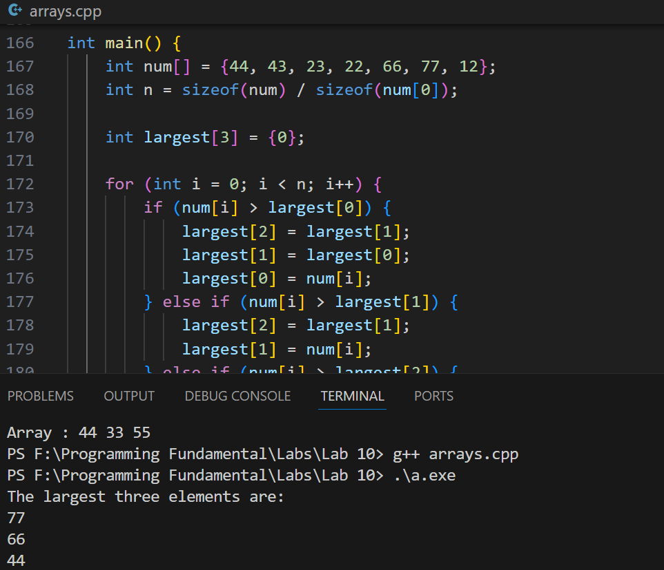
#include <iostream>
using namespace std;

int main() {
int num[] = {44, 43, 23, 22, 66, 77, 12};
int n = sizeof(num) / sizeof(num[0]);

int largest[3] = {0}; // Array to store the largest three elements

for (int i = 0; i < n; i++) {
if (num[i] > largest[0]) {
largest[2] = largest[1];
largest[1] = largest[0];
largest[0] = num[i];
} else if (num[i] > largest[1]) {
largest[2] = largest[1];
largest[1] = num[i];
} else if (num[i] > largest[2]) {
largest[2] = num[i];
}
}

cout << "The largest three elements are: " << endl;
cout << largest[0] << endl;
cout << largest[1] << endl;
cout << largest[2] << endl;

return 0;
}

- Write a C++ program to take n number of inputs and sort a given unsorted array of integers, in wave form.
Note: An array is in wave form when array[0] >= array[1] <= array[2] >= array[3] <= array[4] >= . .
Input: {4, 12, 15, 2, 20, 30, 21}
Output: {4 2 15 12 21 20 30}

#include <iostream>
#include <algorithm>
using namespace std;

int main() {
int n;
cout << "Enter the number of elements: ";
cin >> n;

int arr[100];
cout << "Enter the elements: ";
for (int i = 0; i < n; i++) {
cin >> arr[i];
}
sort(arr, arr + n);
for (int i = 1; i < n; i += 2) {
if (i < n) {
int temp = arr[i];
arr[i] = arr[i - 1];
arr[i - 1] = temp;
}
}
cout << "Array : ";
for (int i = 0; i < n; i++) {
cout << arr[i] << " ";
}
cout << endl;
return 0;
}
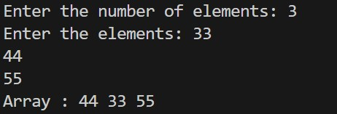

- Write a C++ program to move all negative elements of an array of integers to the end of the array without changing the order of positive elements and negative elements.

#include <iostream>
using namespace std;

int main() {
int n;
cout << "Enter the number of elements: ";
cin >> n;

int arr[100];
cout << "Enter the elements: ";
for (int i = 0; i < n; i++) {
cin >> arr[i];
}

int temp[100];
int posIndex = 0;

for (int i = 0; i < n; i++) {
if (arr[i] >= 0) {
temp[posIndex] = arr[i];
posIndex++;
}
}

for (int i = 0; i < n; i++) {
if (arr[i] < 0) {
temp[posIndex] = arr[i];
posIndex++;
}
}

for (int i = 0; i < n; i++) {
arr[i] = temp[i];
}

cout << "Array after moving negatives to the end: ";
for (int i = 0; i < n; i++) {
cout << arr[i] << " ";
}
cout << endl;

return 0;
}
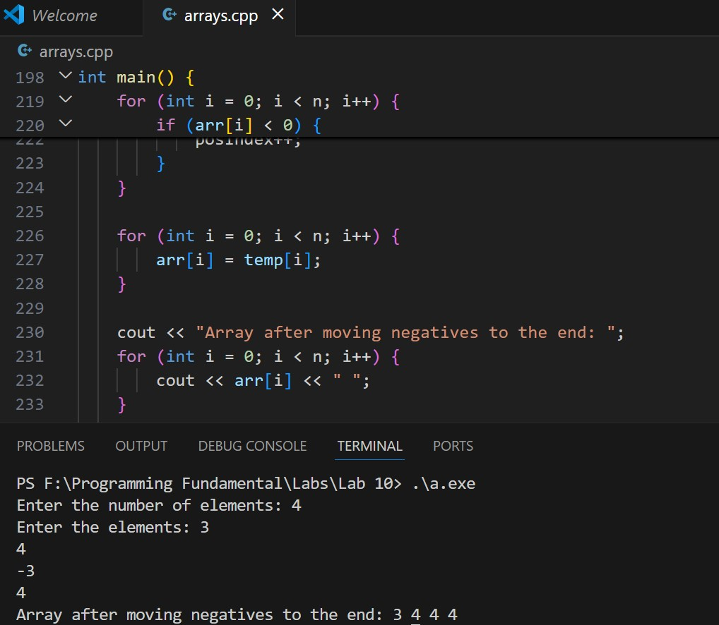

- Create a program to manage student grades using a 2-dimensional array. Each row of the array represents a student, and each column represents a subject. The program should perform the following tasks:

Input:
- Accept the number of students and the number of subjects from the user.
- For each student and subject, input the student's grade (an integer between 0 and 100).

Calculations:
- Calculate the average grade for each student.
- Calculate the average grade for each subject.

Output:
- Display the grades in a tabular format.
- Display the average grade for each student.
- Display the average grade for each subject.

Constraints:
- The number of students and subjects should be between 1 and 10.

Example Output:

Enter the number of students: 3
Enter the number of subjects: 4

Enter grades for Student 1:
Subject 1: 85
Subject 2: 90
Subject 3: 78
Subject 4: 92

Enter grades for Student 2:
Subject 1: 76
Subject 2: 88
Subject 3: 94
Subject 4: 80

Enter grades for Student 3:
Subject 1: 92
Subject 2: 85
Subject 3: 89
Subject 4: 78

Grades Table:
+---------+---------+---------+---------+---------+
| Student | Sub 1 | Sub 2 | Sub 3 | Sub 4 |
+---------+---------+---------+---------+---------+
| 1 | 85 | 90 | 78 | 92 |
| 2 | 76 | 88 | 94 | 80 |
| 3 | 92 | 85 | 89 | 78 |
+---------+---------+---------+---------+---------+

Average Grades:
+---------+------------------+
| Student | Average Grade |
+---------+------------------+
| 1 | 86.25 |
| 2 | 84.5 |
| 3 | 86 |
+---------+------------------+

+---------+------------------+
| Subject | Average Grade |
+---------+------------------+
| Sub 1 | 84.33 |
| Sub 2 | 87.67 |
| Sub 3 | 87 |
| Sub 4 | 83.33 |
+---------+------------------+

Hints:
- Use nested loops for input and output.
- You can use a 2-dimensional array to store student grades.
- Calculate averages row-wise for student averages and column-wise for subject averages.

